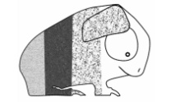

RVCC 2018/20 Nomination

Please check all that you are applying for (you can apply for more than one)

Chairman
President
Secretary/Treasurer
General Committee
RVCC Standards Committee
RVCC Judging Panel
BCC Representative

In 50 words or less please describe why you would be appropriate for the position(s) you are applying for.

Proposer: _______________________________________________ (print name)

Proposer: _______________________________________________ (signature)

Seconder: _______________________________________________ (print name)

Seconder: _______________________________________________ (signature)

Nominee: _______________________________________________ (print name)

Nominee: _______________________________________________ (signature)

Date:

Once completed - please post to

Pam Ramsden
61 Bromwich Street
Bolton, BL2 1JE

